**Name: salini k.b**

**Roll No:33**

**Batch:mca-B**

**Date:**

**NETWORKING & SYSTEM ADMINISTRATION LAB**

**Experiment No.: 2**

**Aim**

Hardware components

**Procedure**

HARDWARE COMPONENTS

1]MOTHERBOARD

The motherboard is the main circuit board of your computer and is also known as the mainboard or logic board. If you ever open your computer, the biggest piece of silicon you see is the motherboard. Attached to the motherboard, you'll find the CPU, ROM, memory RAM expansion slots, PCI slots, and USB ports.

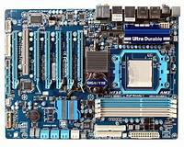

2]MONITOR

A monitor is an electronic output device that is also known as a **video display terminal** (VDT) or a **video display unit** (VDU). It is used to display images, text, video, and graphics information generated by a connected computer via a computer's video card. Although it is almost like a TV, its resolution is much higher than a TV. The first computer monitor was introduced on **1 March 1973**, which was part of the Xerox Alto computer system.

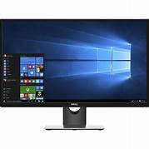

3]PRINTER

A printer is a hardware output device that is used to generate hard copy and print any document. A document can be of any type such as a text file, image, or the combination of both. It accepts input command by users on a computer or on other devices to print the documents. For example, if you have to submit a project report at your college, you need to create a soft copy of your report and print it with the help of the printer.

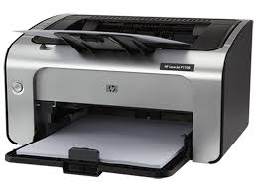

4]PROCESSOR

A processor is an integrated electronic circuit that performs the calculations that run a computer. A processor performs arithmetical, logical, input/output (I/O) and other basic instructions that are passed from an operating system (OS). Most other processes are dependent on the operations of a processor.

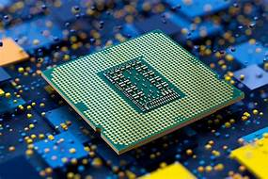

5]RAM

RAM (Random Access Memory) is the hardware in a computing device where the operating system (OS) application programs and data in current use are kept so they can be quickly reached by the device's processor. RAM is the main memory in a computer. It is much faster to read from and write to than other kinds of storage, such as a hard disk drive (HDD), solid-state drive (SSD)or optical drive.

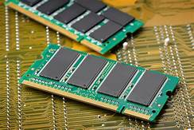

6]ROM

Read Only Memory (ROM) is computer memory that can permanently store data and applications within it. There are various types of ROM with names like EPROM (Eraseable ROM) or EEPROM (Electrically Eraseable ROM).

Unlike RAM, when a computer is powered down, the contents of the ROM are not lost. EPROM or EEPROM can have their contents rewritten by a special operation. This is called 'Flashing the EPROM' a term that came about because ultra violet light is used to clear the contents of the EPROM.

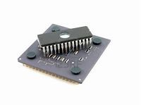

7]SYSTEM UNIT

A typical desktop computer is composed of a computer system unit, a keyboard, a mouse, and a monitor. The computer system unit is the outer shell of all other main internal components of the computer. It is also called a computer case, computer case, or computer tower. The housing is usually made of steel or aluminum, but plastics can also be used.

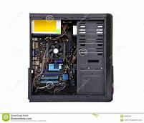

8]CPU

Stands for "Central Processing Unit." The CPU is the primary component of a computer that processes instructions. It runs the operating system and applications, constantly receiving input from the user or active software programs. It processes the data and produces output, which may be stored by an application or displayed on the screen.

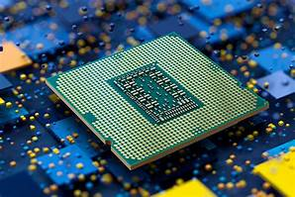

9]MOUSE

A mouse is a hand-held device used for directly interacting with a graphical gui interface y controlling the movement of a cursor or pointer on a computer Display screen. The mouse detects the two-dimensional motion of the operator and translates it into the movement of the cursor on the screen. The most common operations are point-and-click and drag-and-drop.

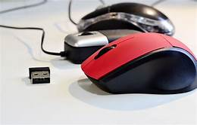

10]KEYBOARD

The keyboard is the piece of [computer hardware](https://www.lifewire.com/computer-hardware-2625895) used to input text, characters, and other commands into a computer or similar device.

Even though the keyboard is an external [peripheral device](https://www.lifewire.com/peripheral-device-2625951) in a desktop system (it sits outside the main [computer housing](https://www.lifewire.com/what-is-a-computer-case-2618149)), or is "virtual" in a tablet PC, it is an essential part of the complete computer

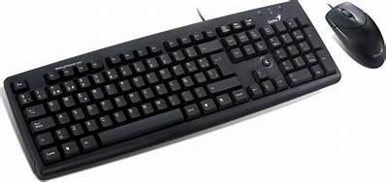system.

11]Flash memory card

The keyboard is the piece of [computer hardware](https://www.lifewire.com/computer-hardware-2625895) used to input text, characters, and other commands into a computer or similar device.

Even though the keyboard is an external [peripheral device](https://www.lifewire.com/peripheral-device-2625951) in a desktop system (it sits outside the main [computer housing](https://www.lifewire.com/what-is-a-computer-case-2618149)), or is "virtual" in a tablet PC, it is an essential part of the complete computer system.

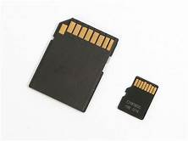

12]STORAGE

* Primary Storage Devices: It is also known as internal memory and main memory. This is a section of the CPU that holds program instructions, input data, and intermediate results. It is generally smaller in size.

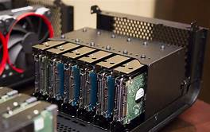

13]INPUT DEVICES AND OUTPUT DEVICES

The functioning of a computer system is based on the combined usage of both input and output devices. Using an input device we can give instructions to the computer to perform an action and the device reverts to our action through an output device.

14]GPU[GRAPHICS PROCESS UNIT]

A **graphics processing unit** (**GPU**) is a specialized electronic circuit designed to rapidly manipulate and alter [memory](https://en.wikipedia.org/wiki/Memory_(computing)) to accelerate the creation of images in a frame buffer intended for output to a display device. GPUs are used in embedded systems, mobile phones personal computers, workstations and game consoles.

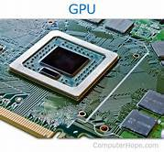

15]CONTROL UNIT

It is the responsibility of the Control Unit to tell the computer’s memory, arithmetic/logic unit and input and output devices how to respond to the instructions that have been sent to the processor.

